**Reg. No: 21BCE1297 Name: Vidhi Shah Date: 28/04/22**

**PPS14**

**Q1**

**Aim:**

Write a basic C++ program to generate Fibonacci series for ‘n’ numbers using inline functions.

**Procedure:**

**Input:**

Number of elements of Fibonacci Series, n

**Output:**

Fibonacci series of n elements

**Algorithm:**

**Inline Fibonacci Function:**

Step 1: Declare function as inline

Step 2: Initialise a, b, c. a=0, b=1

Step 3: Repeat steps 4 to 5 n times

Step 4: If i = 0 or i = 1 then print i

Step 5: Else

Step A: c = a + b

Step B: a = b

Step C: b = c

Step D: Print c

**Main Function:**

Step 1: Read n

Step 2: Call Inline Fibonacci function

Step 3: Return 0

**Code:**

#include <iostream>

using namespace std;

inline void fib(int n) {

    int a = 0, b = 1, c, i;

    for (i = 0; i<n; i++) {

        if (i < 2)

        cout << i << " ";

        else {

            c = a + b;

            a = b;

            b = c;

            cout << c << " ";

        } } }

int main() {

    int n;

    cout << "Enter N: ";

    cin >> n;

    cout << "Fibonacci Series: ";

    fib(n);

    return 0;}

**Output:**

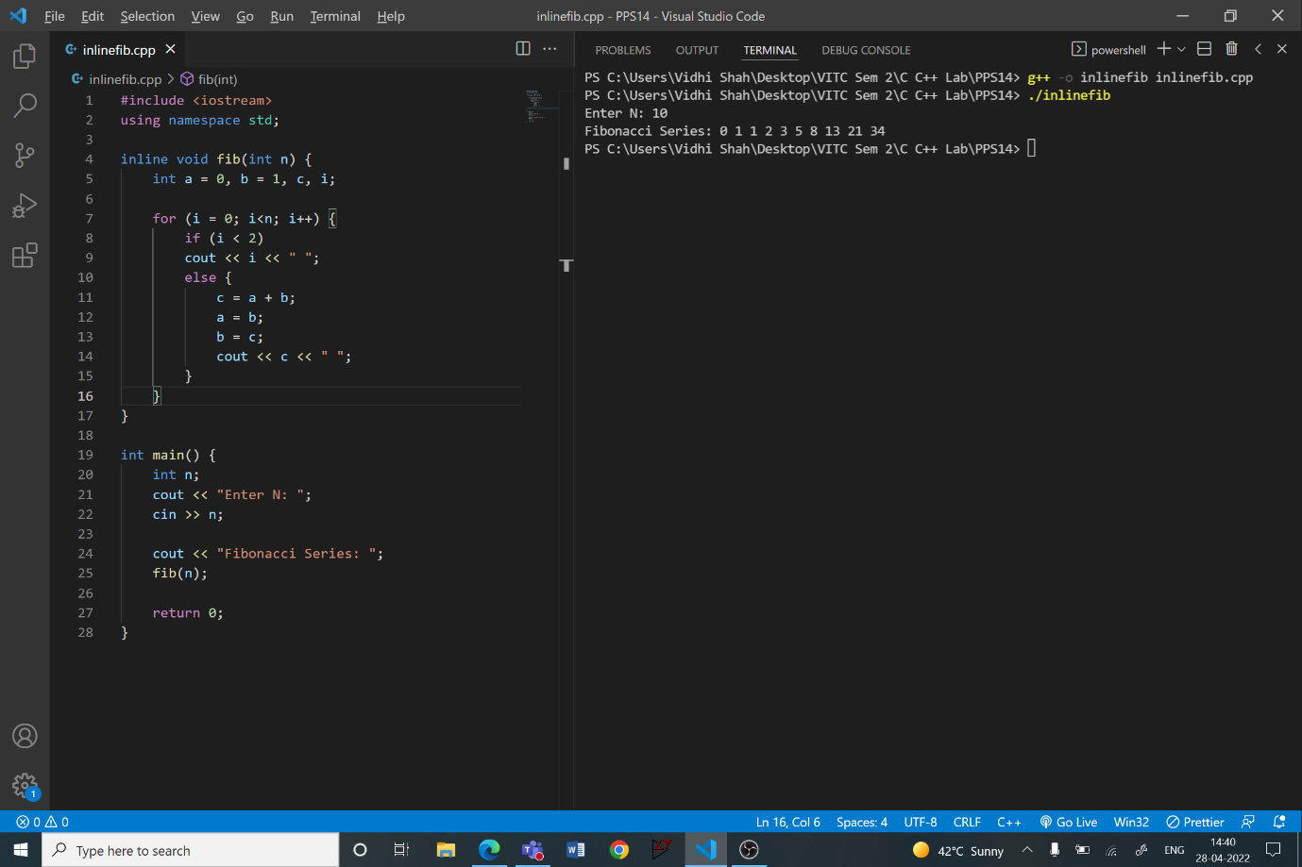

**Q2**

**Aim:**

Create a class named 'Rectangle' with two data members- length and breadth and a function to calculate the area which is 'length*breadth'. The class has three constructors which are:

1 - having no parameter - values of both length and breadth are assigned zero. 2 - having two numbers as parameters - the two numbers are assigned as length and breadth respectively.

3 - having one number as parameter - both length and breadth are assigned that number.

Now, create objects of the 'Rectangle' class having none, one and two parameters and print their areas

**Procedure:**

**Input:**

Length or breadth of the rectangle or void input

**Output:**

Area

**Algorithm:**

**Class Rectangle:**

Step 1: Create a class Rectangle

Step 2: Add private data members, length, breadth and area

Step 3: Add public constructs for:

1. **No parameters:** length = 0, breadth = 0
2. **2 parameters (x, y):**  length = x, breadth = y
3. **1 parameter (x):** length = x, breadth = x

Step 4: Add public member function

1. **Area:** Calculate and print area

**Main Function:**

Step 1: Create 3 objects from class rectangle, with no parameter, 1 parameter

and 2 parameters respectively

Step 2: Call the area function for 3 objects

Step 3: Return 0

**Code:**

#include <iostream>

using namespace std;

class Rectangle {

    private:

    int l, b, a;

    public:

    Rectangle() {

        l = 0;

        b = 0;

    }

    Rectangle(int x, int y) {

        l = x;

        b = y;

    }

    Rectangle(int x) {

        l = x;

        b = x;

    }

    void area () {

        a = l*b;

        cout << "Length: " << l;

        cout << "\nBreadth: " << b;

        cout << "\nArea: " << a << "\n\n";

    }

};

int main() {

    Rectangle c1;

    Rectangle c2(5, 10);

    Rectangle c3(5);

    cout << "\n";

    c1.area();

    c2.area();

    c3.area();

    return 0;

}

**Output:**

